Note to self: Each time you work on the project, you should enter the date, start time and end time. You should document the references you consult, the main points from your reading, important tables or circuits from your reading, the ideas you have, the circuits you design, the software you write, simulation and experimental test results, your successes and failures, etc. You will submit your current notebook each week along with your weekly report, see below.

**Illa’s 2804 Project Notebook**

Click on the hyperlink to see the start of the notes taken during the referenced milestone

*Table of contents*

*P2 …………………………………… Milestone 1 notes*

*P9…………………………………… Milestone 2 notes*

# *P16 …………………………………… Milestone 3 notes*

*P21 …………………………………… Milestone 4 notes*

## 7/14/21

## 2:17pm – 3:00pm

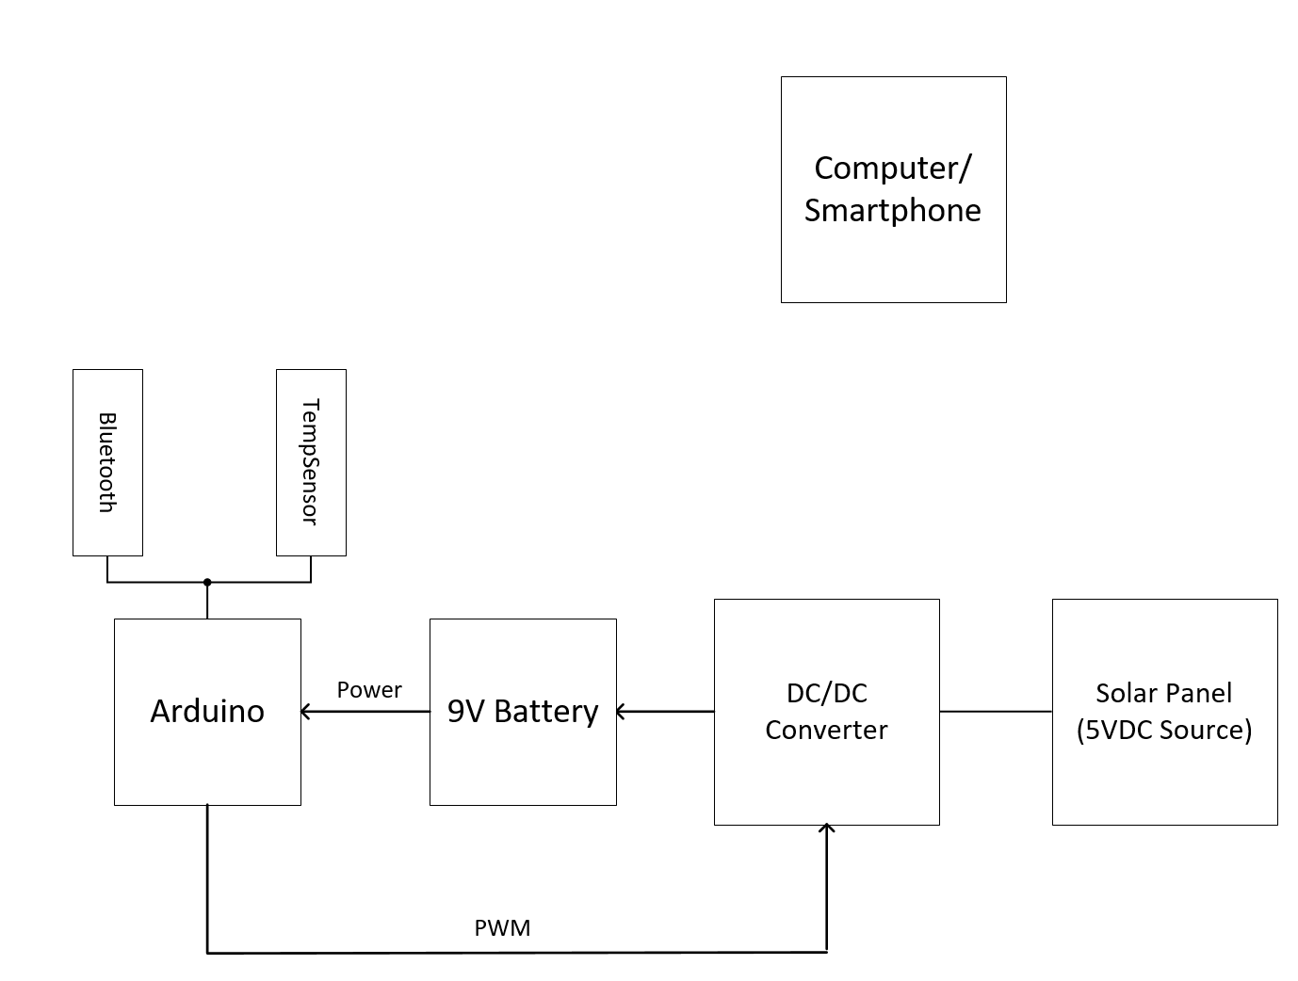

Preliminary Research (sites visited and articles read):

<https://en.wikipedia.org/wiki/DC-to-DC_converter> (Wikipedia page on DC/DC converter)

Converter_Steady_State_Analysis.pdf (Info for DC/DC converter circuit I think?)

<http://ww1.microchip.com/downloads/en/devicedoc/20001942g.pdf> (datasheet for temp sensor)



## 7/14/21

## 6:21pm – 7:40pm

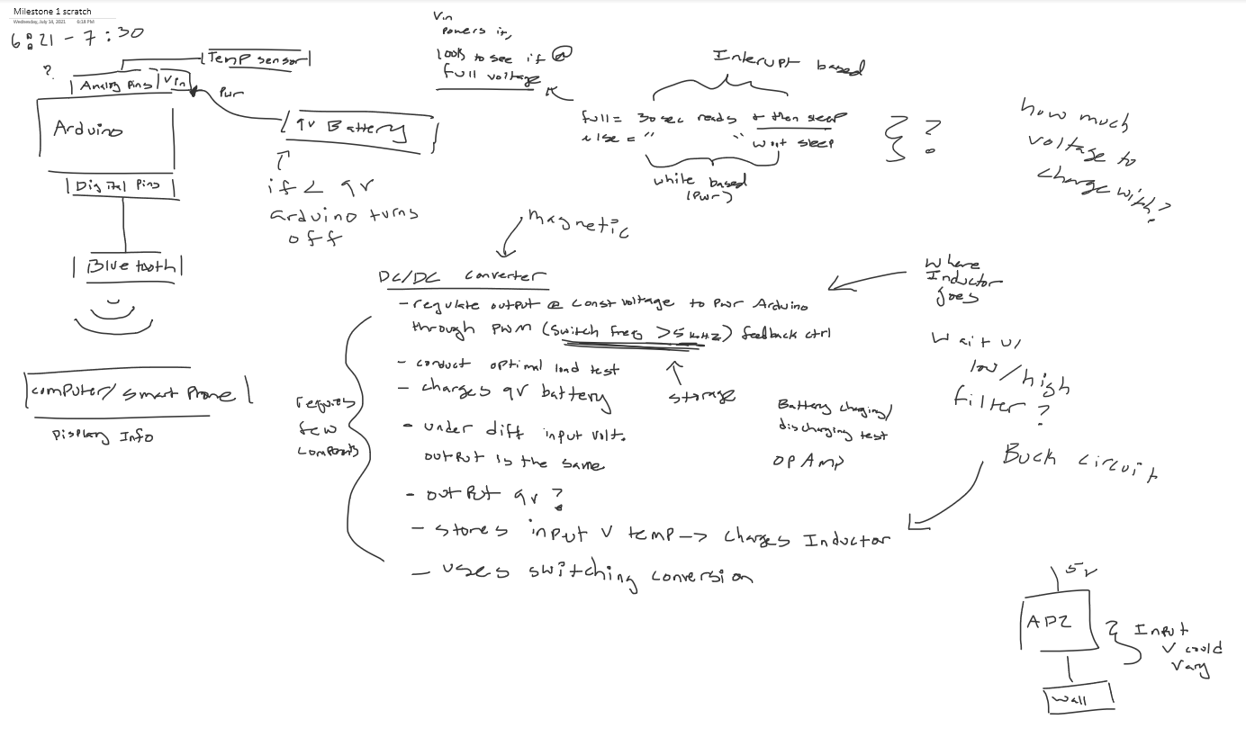

## 7/15/21

## 1:00am – 1:55 am

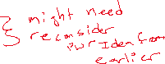

Arduino References (Read or watched to refresh memory / find info)

<https://www.arduino.cc/en/Guide/ArduinoUno>

<https://www.youtube.com/watch?v=_ItSHuIJAJ8>

## 7/15/21

## 11:42am –2:00pm



Site used: <https://www.analogictips.com/pulse-width-modulation-pwm/>

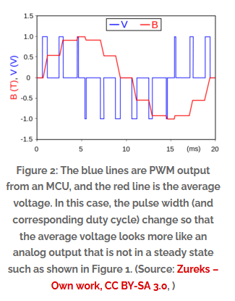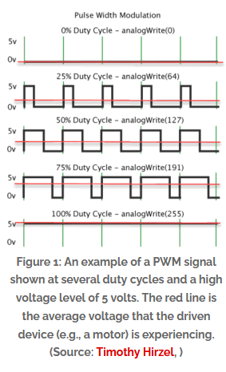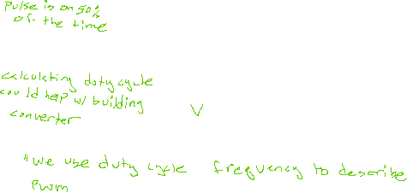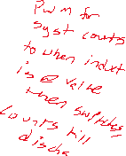

## 

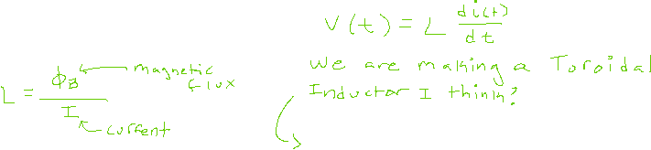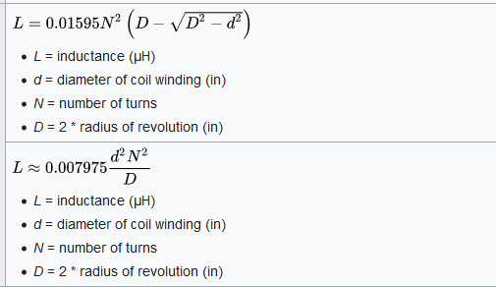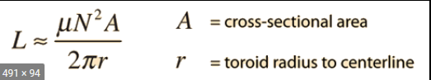

## 7/15/21

## 5:20pm- 7:20

Useful for programming Bluetooth: <https://www.geeksforgeeks.org/all-about-hc-05-bluetooth-module-connection-with-android/>

Talked with partner and finalized report. Made clean version of block diagram and wrote part of the outline

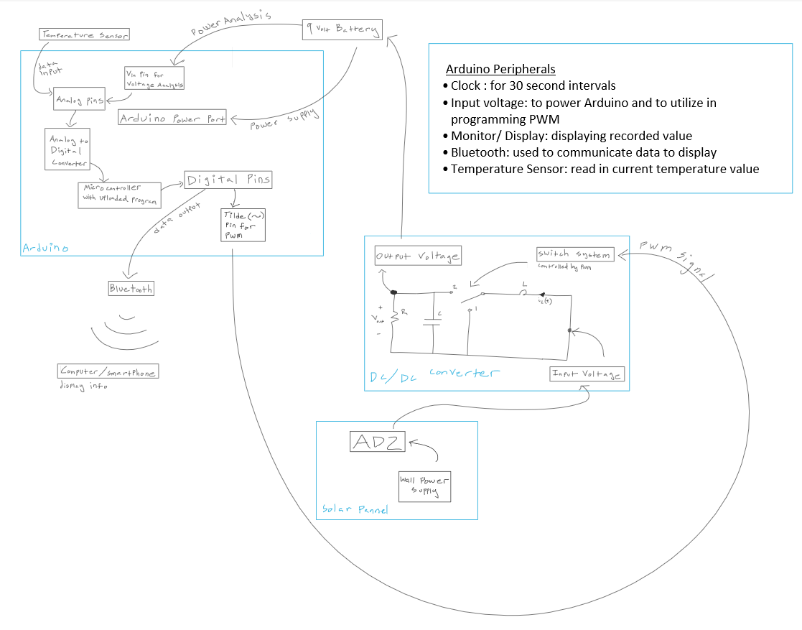

## 7/20/21

## 5:10pm – 7:00pm

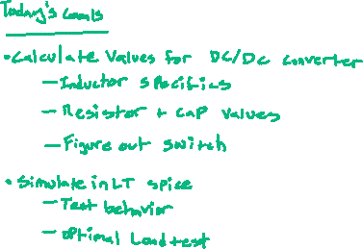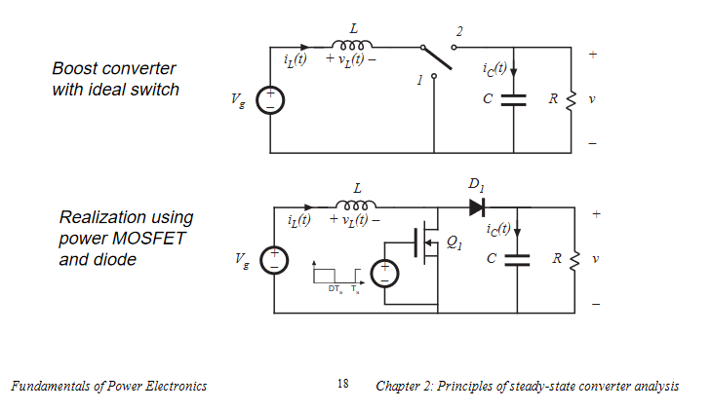

[https://www.powerelectronicsnews.com/the-dc-dc-boost-converter-power-supply-design-tutorial-](https://www.powerelectronicsnews.com/the-dc-dc-boost-converter-power-supply-design-tutorial-section-5-1/)

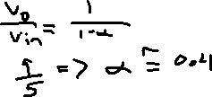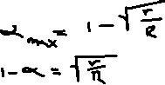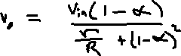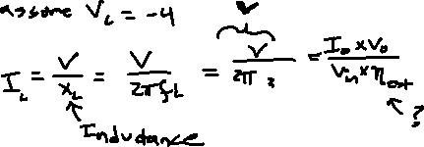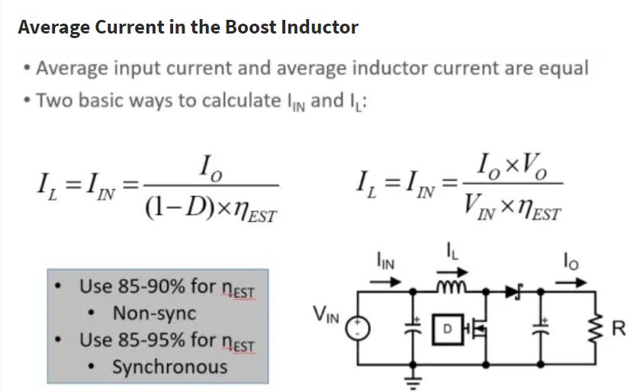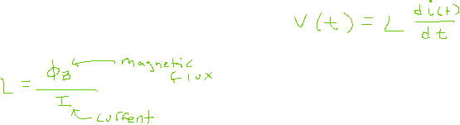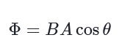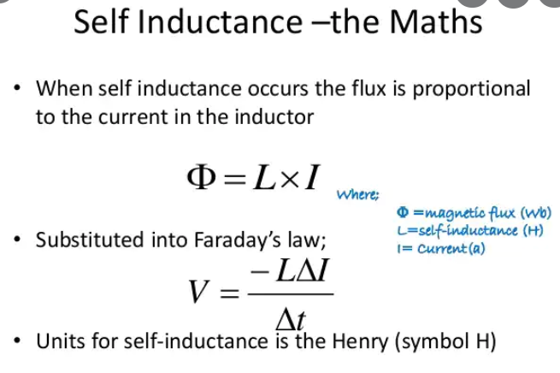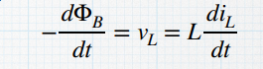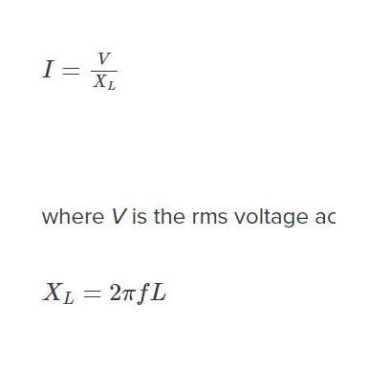

<https://www.powerelectronicsnews.com/the-dc-dc-boost-converter-power-supply-design-tutorial-section-5-1/>

## 7/21/21

## 2:00pm – 3:06pm

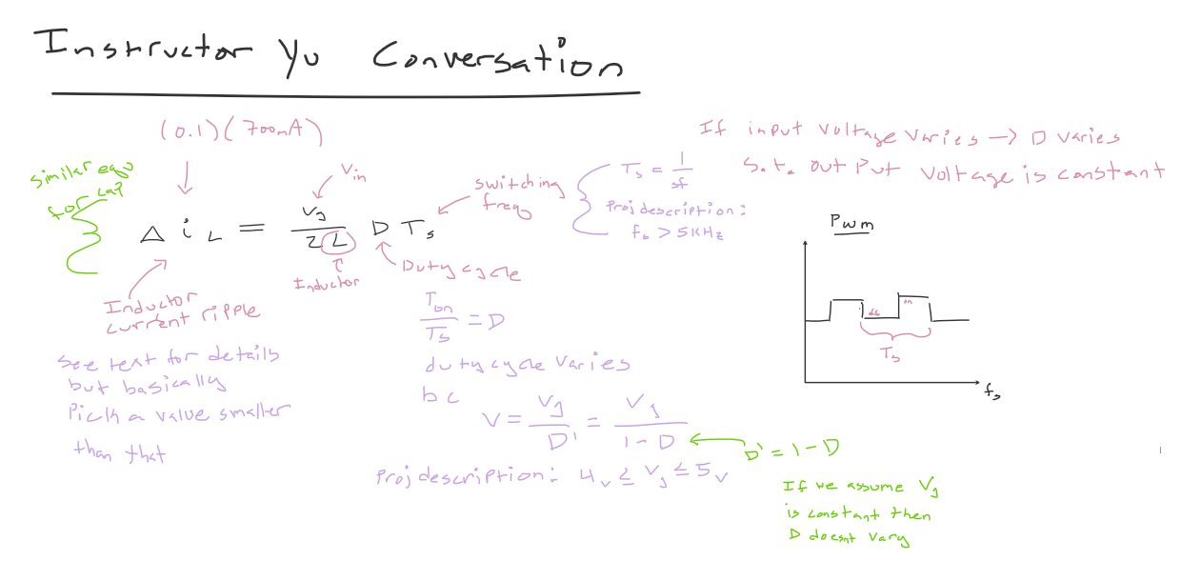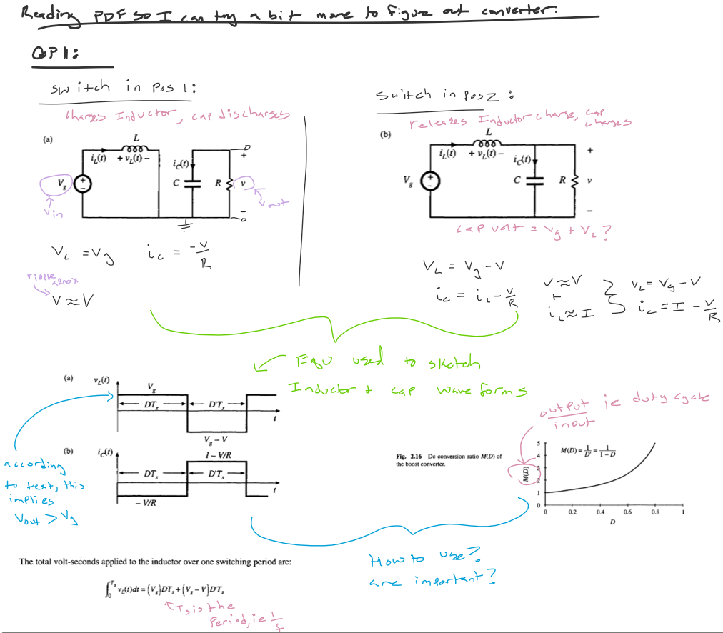

## 7/21/21

## 5:00pm – 7:00pm

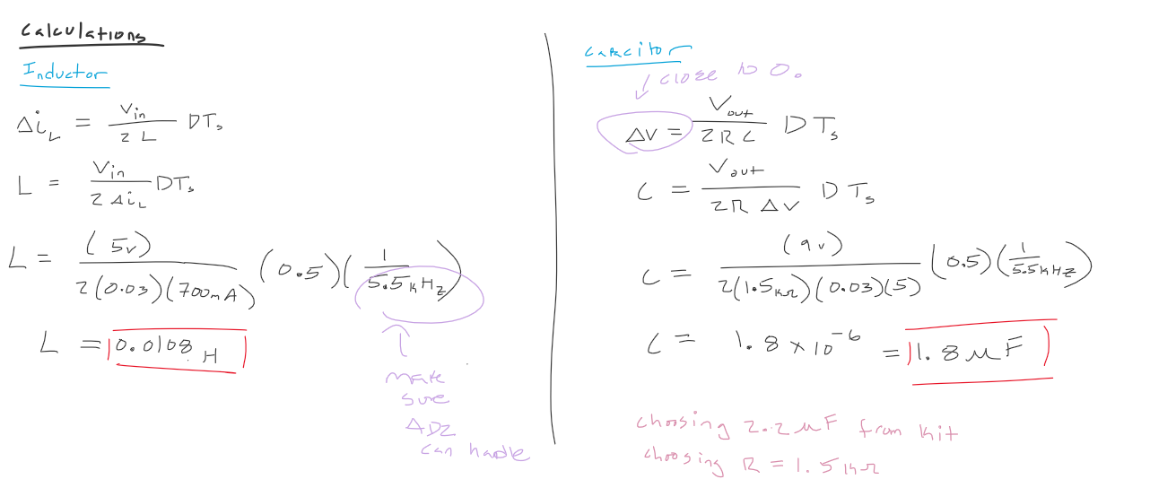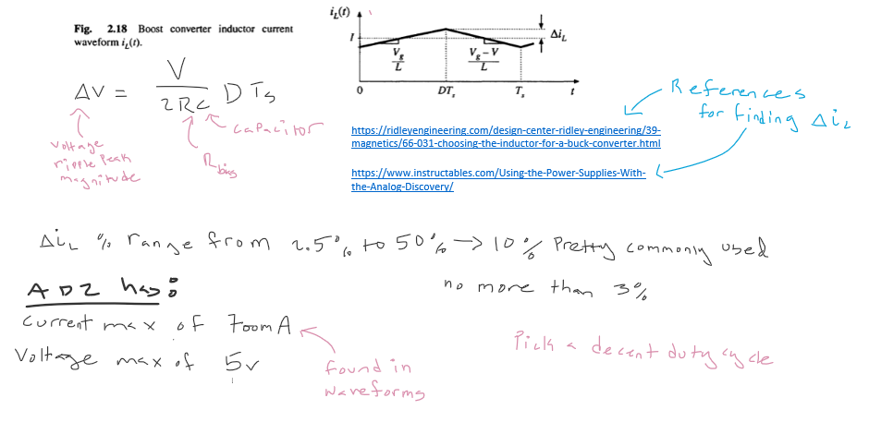

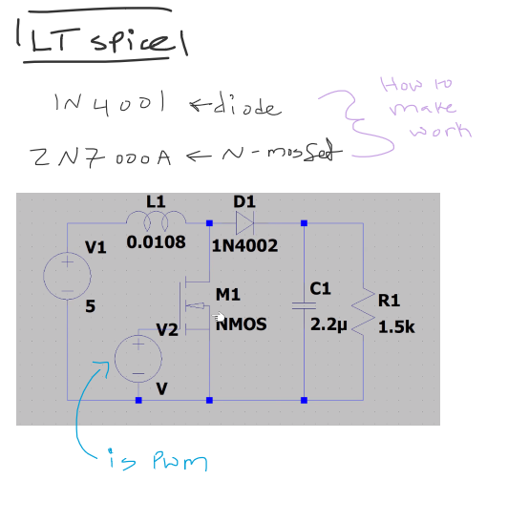

## 7/23/21

## 3:30pm – 11:00pm (some breaks taken)

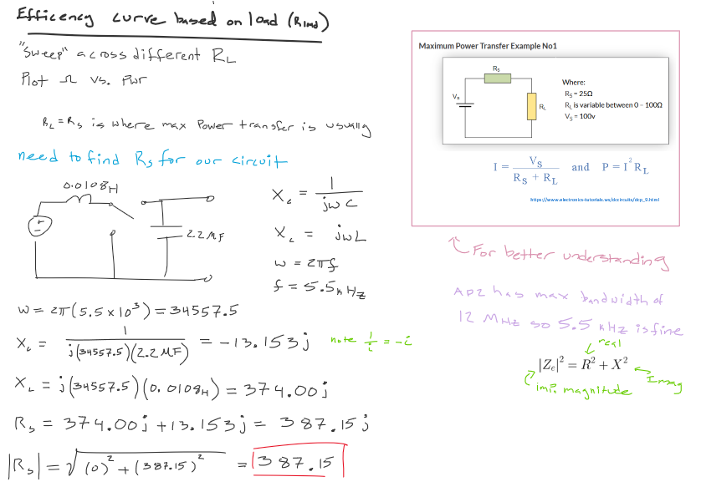Worked by self to make changes to LT Spice recommended. Also worked on refining block diagram for report and creating the Optimal Load Test graph. Uncertain if calculations are correct. Will check later.

## 7/24/21

## 3:00pm – 7:00pm

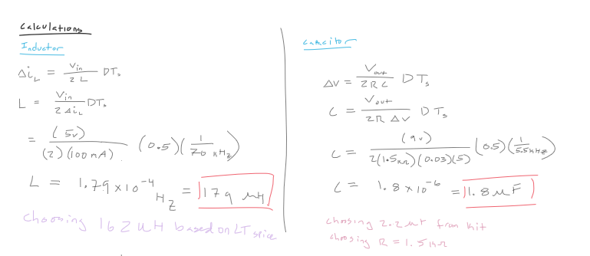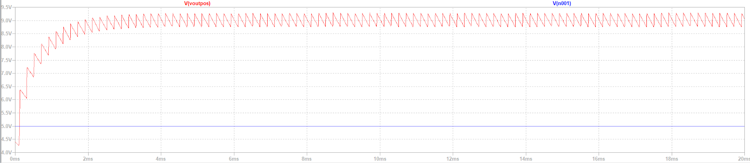Just refined math, redid calculations and wrote final report

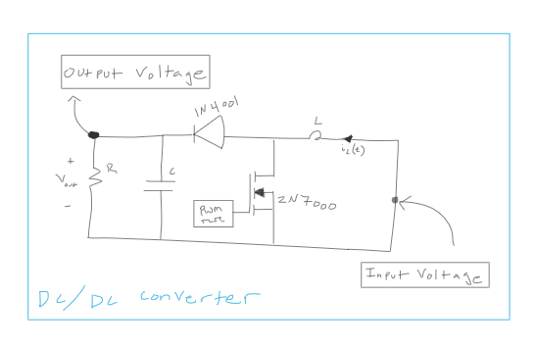

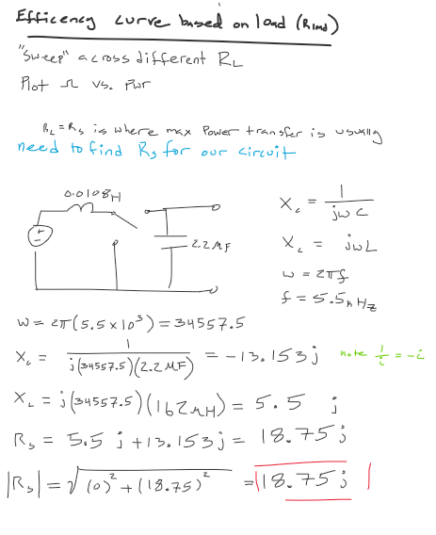

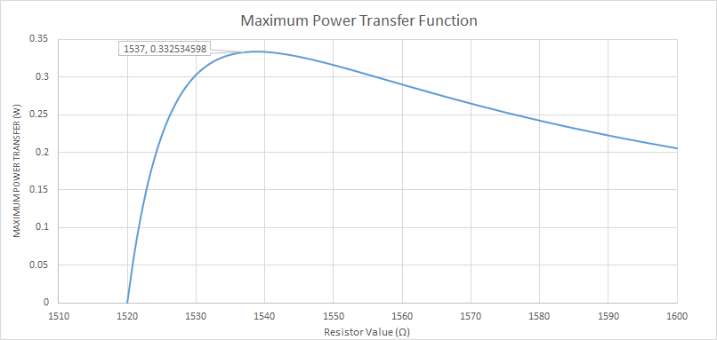

## 7/28/21

## 5:30pm – 9:00pm

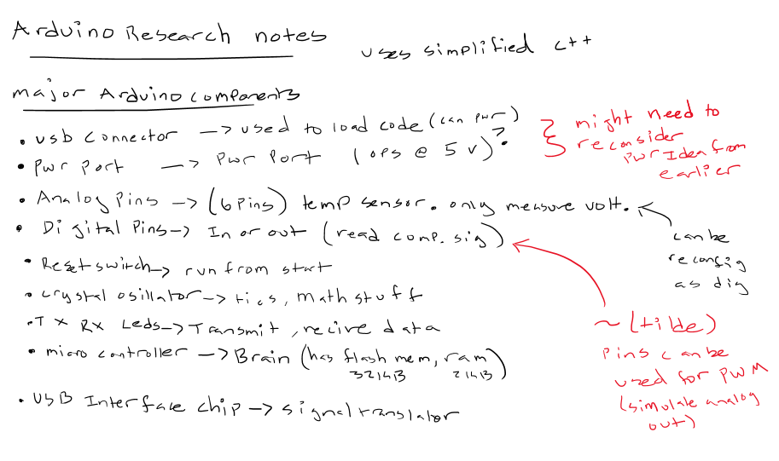

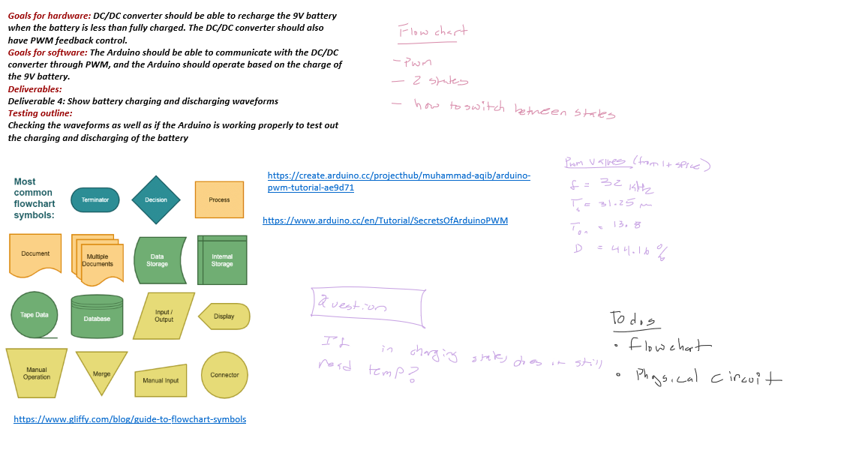

## 7/29/21

## 12:00pm – 2:00pm

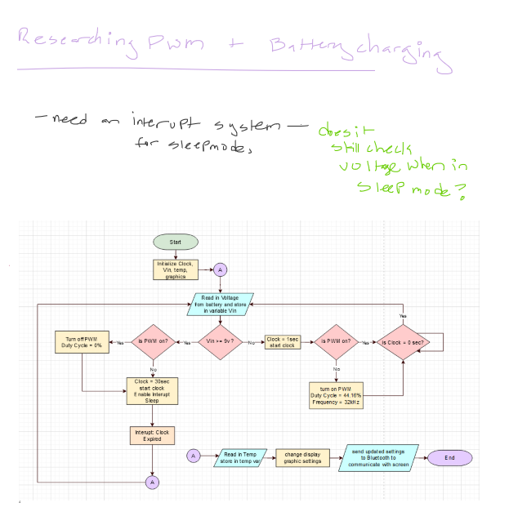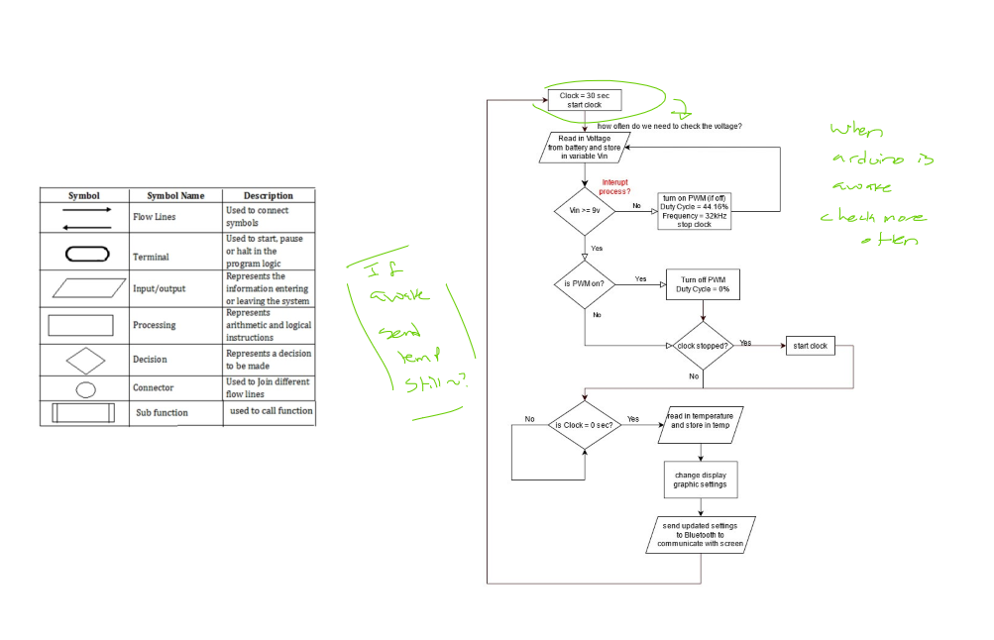

## 7/30/21

## 6:00pm – 9:00pm

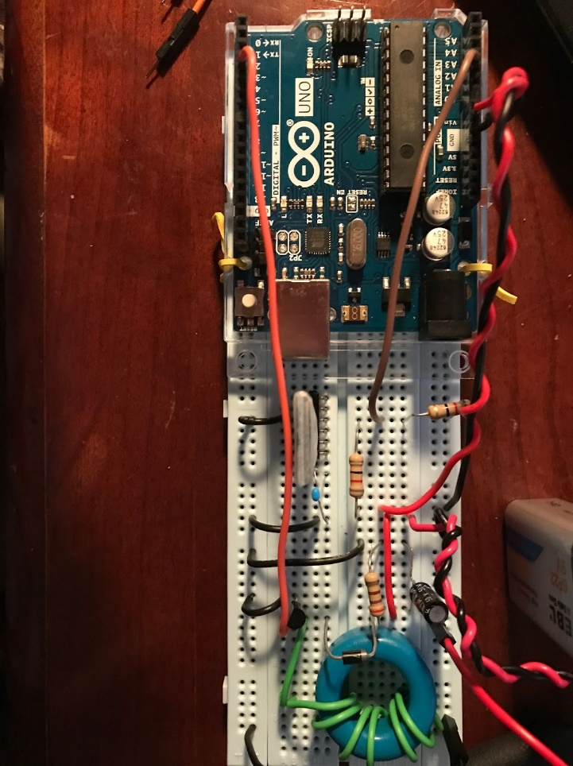

Built physical circuit while Saashi wrote the program

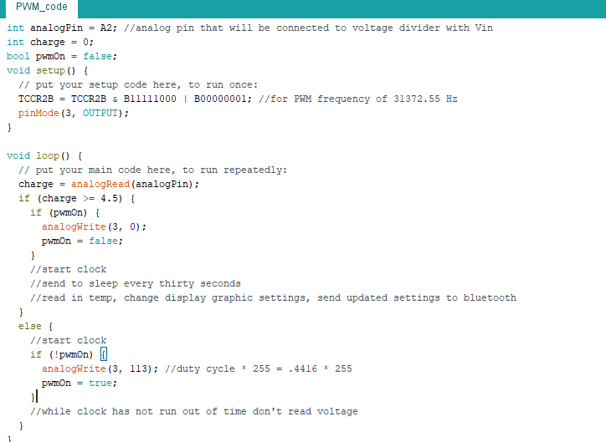

Output of circuit with a waveform generator wave being used as a substitute PWM

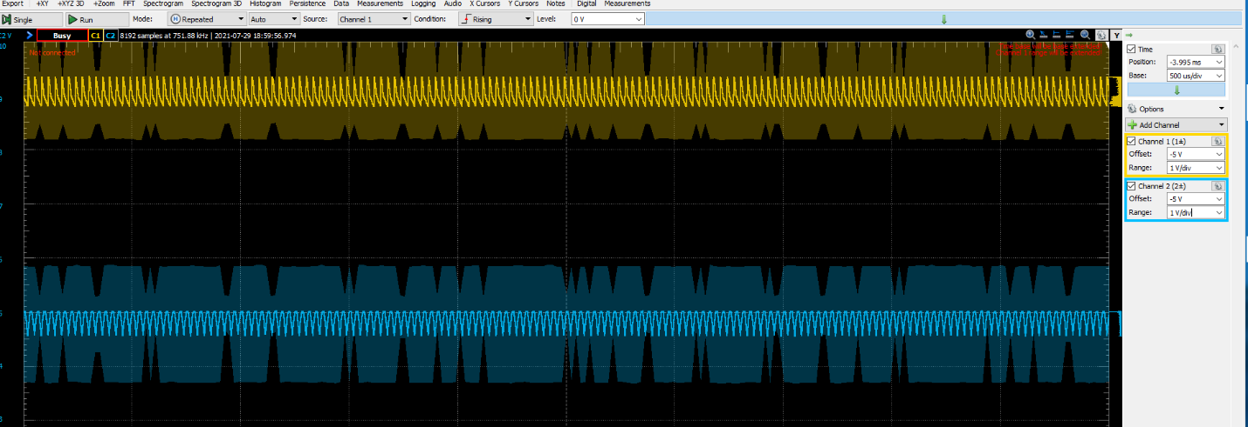(blue is Vin, Yellow is Vout)

## 7/31/21

## 6:00pm – 11:00pm

Final testing of physical circuit done in waveforms below blue is the Arduino’s PWM, yellow is the output voltage charging the battery. Milestone report was written and submitted. This was submitted later

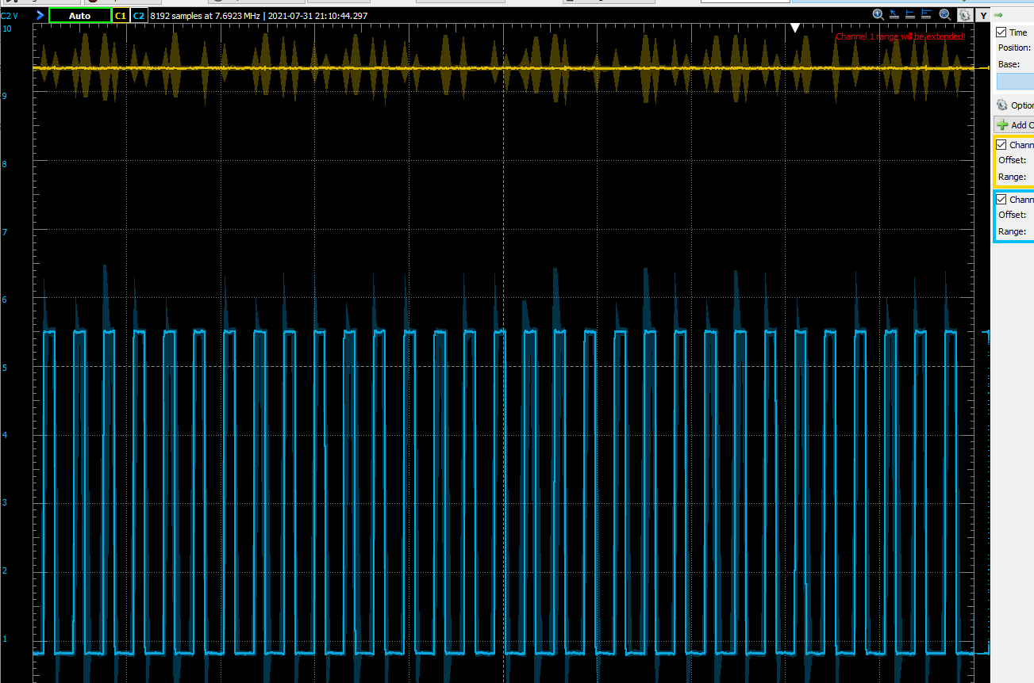

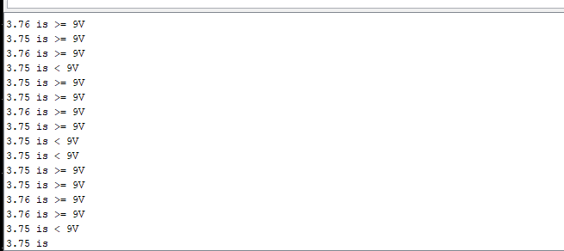

## 8/2/21

## 12:00pm – 2:00pm

## 8/3/21

## 2:00pm – 8:30pm (some breaks taken)

## 8/4/21

## 5:00pm – 10:30pm

just worked on battery charging curve

## 8/5/21

## 1:00pm – 2:30pm

## 8/5/21

## 5:00pm – 9:30pm

started working on interrupt system. Partner was supposed to help, but she just kinda threw the work on me.

worked on code for interrupt and timer. Sent a few emails to ask questions while building it. I forgot to screen shot the code. I worked on a smaller file instead of the final code so I could test with an LED

## 8/6/21

## 5:00pm – 9:30pm

finished the program finally. Also wrote parts of the report and edited the entire thing. Added what is seen below to final code.

## 8/7/21

## 6:00pm – 11:30pm

//figuring out interupts and timers

#include <avr/sleep.h> //do I need this?

#include <SoftwareSerial.h>

int LED = 13; //pin of LED being used

int timerDone = 0;

const uint16_t t1_load = 0; //counter value

const uint16_t t1_compareVal = 31250; //comparison val got from calulating prescalar of 1024 for timer of 2 sec

void setup() {

Serial.begin(9600); //send and recive at 9600 BaudRate

pinMode(LED, OUTPUT);//Set the pin to be OUTPUT for LED

TCCR1A = 0; //resetting Timer1 register A to zero

//setting prescalar to 1024

TCCR1B |= (1 << CS12);

TCCR1B &= ~(1<< CS11);

TCCR1B |= (1 << CS10);

//Reset Timer1 and set the compare value

TCNT1 = t1_load;

OCR1A = t1_compareVal;

TIMSK1 = (1 << OCIE1A); //enable Timer1 compare interrupt

sei(); //enable global interupts

}

//a method to put the arduino to sleep for 8 seconds

void SleepyTimeMode(){

set_sleep_mode(SLEEP_MODE_IDLE); //set mode to full sleep mode

sleep_enable(); //enabling sleep mode

digitalWrite(LED, LOW);

delay(1000); //short delay to turn off LED.

sleep_mode(); //activate sleep mode

sleep_disable();

Serial.print("timer Expired \n"); //wake up here

}

void loop() {

// put your main code here, to run repeatedly:

// Serial.print("test\n");

if (timerDone == 1){

timerDone = 0;

digitalWrite(LED, HIGH);

delay (1000);

for (int x = 0; x < 30; x++){

SleepyTimeMode();

}

}

//digitalWrite(LED,HIGH); //Write new state to LED

//delay(500);

}

//Interupt service for timer1

ISR(TIMER1_COMPA_vect) {

TCNT1 = t1_load; //reset pin to zero

//PORTB ^= ~(1 << LED);

// digitalWrite(LED, HIGH);

if(timerDone == 0){

timerDone = 1;

}

}

There weren’t any specific new developments beyond developing the power point presentation and trying to debug the project further. The final report was written and submitted. Definitely frustrated with partner who left me to implement at least 2/3 of the project.

Last Week